From black boxes to chemical interpretability: explainable deep learning for mutagenicity prediction

D. Khasanova^{*a,b,c}, F. Menezesª, F. Ballabioª, C. H. Schwab^{c}, O. Sacher^{c}, T. Magdziarz^{c}, C. Barber^{e}, and I. V. Tetko^{a,d}

* Corresponding author

ª Helmholtz Munich – German Research Center for Environmental Health (GmbH), Institute of Structural Biology, Molecular Targets and Therapeutics Center, 85764 Neuherberg, Germany
^{b} TUM School of Natural Sciences, Technical University of Munich, 85748 Garching, Germany
^{c} Molecular Networks GmbH (MN-AM), Neumeyerstr. 22-34, 90411 Nuremberg, Germany
^{d} BIGCHEM GmbH, Valerystr. 49, 85716 Unterschleißheim, Germany
^{e} Lhasa Limited, Granary Wharf House, 2 Canal Wharf, Leeds LS11 5PS, United Kingdom

Abstract
Recent advances in transformer-based models, originally developed for natural language processing, have demonstrated strong performance in molecular property prediction, including toxicity assessment. However, the current challenge is no longer limited to improving predictive accuracy, but rather to understanding the underlying factors driving these predictions and evaluating how well they align with established chemical knowledge. A variety of explainable artificial intelligence (XAI) techniques have been proposed, each tailored to specific model architectures and interpretability goals. In our previous work, we demonstrated that highly accurate models can correctly identify known toxicophores. Nevertheless, these models often fail when toxicity cannot be attributed solely to well-defined substructures, leading to incorrect predictions or misleading attributions. This highlights the need to incorporate physicochemical descriptors that capture broader molecular behavior. Relevant properties include Fukui indices (reactivity), steric effects (bulkiness), electronic properties such as partial charges and HOMO–LUMO gap, lipophilicity (logP), polar surface area, and hydrogen-bonding capacity. Integrating such descriptors not only improves predictive performance but also enhances interpretability, enabling models to reason more consistently with chemical principles rather than relying on pattern recognition alone. To support this direction, we provide open-access datasets of semi-empirical and density functional theory (DFT)-derived descriptors, available at: https://github.com/DinaKhasanova/xai_dft.
Introduction
Experimental mutagenicity assessment remains a central component of drug discovery and chemical safety evaluation, as toxicity is one of the primary drivers of compound attrition ^{1,2}. The Ames test ³ is widely used to assess mutagenic potential, but experimental testing is costly, heterogeneous across strains and protocols, and difficult to scale to large chemical libraries. These limitations have motivated the development of computational approaches for mutagenicity prediction ^{4,5}, enabling faster and more cost-effective screening of the chemical space.
The relevance of accurate and interpretable mutagenicity prediction extends beyond efficiency. For safety-critical endpoints, predictive performance alone is insufficient: chemists, toxicologists, and regulatory agencies require mechanistic insight into why a compound is predicted to be mutagenic ⁶. In particular, it is essential to determine whether model predictions are driven by chemically meaningful substructures, such as known toxicophores, or by spurious correlations present in the data. This need has led to increasing interest in explainable artificial intelligence (XAI)⁷, including both intrinsic and post-hoc methods, to improve transparency and trust in predictive models.

Recent advances in molecular machine learning (ML) have been driven by SMILES-based language models, such as SMILES Transformer⁸, ChemBERTa⁹, MolBERT¹⁰, and MoLFormer¹¹. These models leverage large-scale pretraining on molecular strings to learn transferable representations that are competitive with, and in some cases superior to, classical descriptor-based or graph-based approaches. However, SMILES-based models operate purely on sequence information and must infer physicochemical and electronic properties implicitly. This limitation is particularly relevant for endpoints such as mutagenicity, where biological response depends not only on local structural alerts but also on broader physicochemical factors¹² including polarity, charge distribution, electrophilicity, and metabolic activation. To address this limitation, several studies have incorporated physicochemical information into SMILES-based modeling pipelines. Two main strategies have emerged. One strategy for incorporating physicochemical information is descriptor-informed pretraining, in which models are trained not only to reconstruct masked tokens in SMILES sequences but also to predict physicochemical properties. A representative example is MolBERT¹⁰, which introduced a PHYSCHEMPRED additional task requiring the prediction of approximately 200 RDKit descriptors during pretraining. When evaluated separately, the PHYSCHEMPRED objective achieved higher average BEDROC20¹³ scores than masked language modeling, while the best performance was obtained by combining both, indicating that explicit physicochemical supervision provides complementary information to sequence-based learning. In contrast, the original ChemBERTa⁹ was trained solely using masked language modeling without explicit physicochemical targets. Subsequent extensions such as ChemBERTa-2¹⁴ incorporate additional property prediction heads during pretraining, typically focusing on a smaller set of task-relevant descriptors (e.g., logP, molecular weight, or polar surface area), thereby guiding the learned representations without requiring the prediction of hundreds of features.

The second strategy is explicit multimodal fusion at downstream prediction time, in which physicochemical descriptors are combined with learned molecular embeddings. A representative example is MoLFormer¹¹, where 29 selected Mordred descriptors¹⁵ are concatenated with the learned molecular representation, leading to a substantial improvement in classification performance on toxicity tasks, with accuracy increasing from 0.75 to 0.84 compared to the base model. These results illustrate that even a relatively small set of carefully selected physicochemical features can provide complementary information to sequence-based representations, particularly for chemically complex or toxicity-related endpoints, although the extent of improvement depends on the dataset, prediction target, and fusion strategy.

Beyond descriptor-based augmentation of SMILES models, recent work has also explored the use of quantum-mechanical descriptors to capture electronic properties that are directly relevant to toxicity. For example, a recent study¹⁶ on the TDCommons-LD50 dataset demonstrated that combining structural and electronic information can outperform previous state-of-the-art approaches, including 2D graph neural networks, equivariant transformers, and fingerprint-based surrogate models. SHAP analysis indicated that electronic descriptors contribute to toxicity prediction in a manner consistent with established chemical understanding of molecular interactions at biological targets. However, these approaches rely exclusively on descriptor-based representations and do not incorporate sequence-based molecular encodings such as SMILES, limiting their integration with modern molecular language models.

Explainability research in molecular machine learning has developed along largely separate lines ⁷. For SMILES- and graph-based models, attribution methods typically identify important atoms, tokens, or substructures, often highlighting known toxicophores ^{17,18}. In contrast, descriptor-based models are interpreted through feature importance rankings, such as SHAP values, that emphasize global physicochemical properties^{19,20}. While both perspectives provide valuable insights, it remains unclear how they interact within a unified modeling framework. In particular, it is not well understood whether augmenting SMILES representations with physicochemical features affects only predictive accuracy, or whether it also changes the underlying basis of model decisions and the nature of the resulting explanations.

This question is especially important for mutagenicity prediction, where similar structural motifs can lead to different biological outcomes depending on physicochemical context ^{12,21}. For example, aromatic amines are commonly associated with mutagenicity, yet chemical modifications such as acylation can significantly alter their electronic properties and reduce their reactivity. A token-based model may emphasize the shared structural motif, whereas a descriptor-augmented model may instead capture changes in charge distribution, polarity, and electrophilic activation potential, leading to a more mechanistically grounded interpretation. This illustrates a broader conceptual shift: physicochemical augmentation may not only improve predictions but also elevate explanations from purely structural patterns to integrated physicochemical reasoning.

To our knowledge, no study has systematically examined how physicochemical augmentation influences explainability in SMILES-based models. In particular, it remains unclear which types of features (ranging from simple 2D descriptors to more complex electronic descriptors) provide the best balance between predictive performance, explanation quality, and computational cost. In this work, we address this gap by augmenting a SMILES-based molecular language model with physicochemical features within a unified modeling framework. We evaluate the resulting models on mutagenicity prediction and compare them to both token-only and descriptor-based baselines. Beyond predictive accuracy, we perform a systematic analysis of model explanations using a consistent XAI framework, assessing their faithfulness, stability, and alignment with known mutagenic mechanisms. Through this approach, we aim to determine whether physicochemical augmentation not only improves performance but also leads to more chemically meaningful and mechanistically informative explanations.

Methods
Datasets
TDC Ames
The primary dataset used in this study was the AMES mutagenicity benchmark from Therapeutics Data Commons (TDC)²², which provides a binary mutagenic/non-mutagenic label together with a SMILES representation for each compound. The raw TDC download contained 7,278 entries. These were processed with an RDKit-based cleaning pipeline that removed rows with missing or invalid SMILES, stripped salts, excluded multi-fragment records, converted structures to canonical SMILES, removed very long strings, collapsed exact duplicates, and discarded compounds associated with conflicting labels. The final cleaned dataset contained 7,255 compounds, including 3,951 mutagens and 3,304 non-mutagens. Protonation state assignment failed for 4 compounds, so the final 5-fold cross-validation was conducted on 7,251 compounds (3,950 mutagens, 3,301 non-mutagens). The released TDC benchmark does not provide assay-context metadata such as tester strain or S9 metabolic activation status in the working file.
Pesticides and Genotoxicity Data
To determine whether the benefit of adding physicochemical properties increases with larger datasets, we examined the Pesticides and Genotoxicity Data dataset released by Kirchmair et al.²³ This dataset contains 22,627 compounds overall, including 3,682 with no Ames result that were excluded. The remaining entries were processed with the same RDKit-based cleaning pipeline described above, yielding 18,900 compounds.
Two further filters were applied to ensure complete descriptor coverage. Twenty-one entries consisting of a single heavy atom were removed, as per-atom descriptors are undefined for isolated atoms. A further 125 organometallic compounds were removed because Gasteiger partial charges are not parameterised for these elements and evaluated to undefined values, their labels were predominantly negative (99 non-genotoxic, 26 genotoxic). All remaining compounds were verified to yield defined values for every descriptor used in this work. No substitute or fallback values were used at any stage, so every compound in both datasets carries genuine computed descriptors.The final pesticide dataset contained 18,754 compounds, including 7,638 genotoxic and 11,116 non-genotoxic.
Unlike the TDC benchmark, this dataset retains partial assay-context information through an Ames S9 field indicating whether metabolic activation was used. The field aggregates annotations from several source databases. Counting only compounds for which at least one source recorded an explicit condition, S9 status is available for 5,298 of the 18,754 compounds: 4,201 tested under both conditions, 621 without metabolic activation only, and 476 with metabolic activation only. S9 status was not used as a model input.

Model architecture
The model consisted of a pretrained MolEncoder²⁴ backbone followed by a lightweight classification head for binary toxicity prediction. The MolEncoder model was originally trained on large-scale SMILES datasets derived from ChEMBL and PubChem. In this work, we used the published pretrained model and fine-tuned it for downstream toxicity prediction. MolEncoder is an encoder-only transformer that produces contextualized token representations from input SMILES strings. For downstream classification, the final hidden representation of the CLS (classification) token was used as a pooled molecular embedding. The CLS token is a special learnable token added to the beginning of the SMILES sequence in transformer architectures. During self-attention, it aggregates contextual information from all tokens in the sequence, enabling its final hidden state to serve as a representation of the entire molecule. This embedding was then passed to a feed-forward head composed of layer normalization, a linear layer, GELU activation, dropout, and a final linear layer mapping to the binary mutagenicity output. The descriptor-augmented model maintains the pretrained SMILES-only predictor as a fixed backbone. Molecular descriptors are processed through an auxiliary pathway that generates refinement predictions independently. A gating mechanism then combines these predictions by weighting the descriptor-based refinement based on two factors: the confidence of the SMILES-only prediction and the disagreement between the two pathways. The final prediction is computed as:
where is the learned gating function conditioned on prediction confidence and margin , and is the descriptor-derived refinement. This ensures that descriptor information enhances rather than replaces the learned molecular representation.

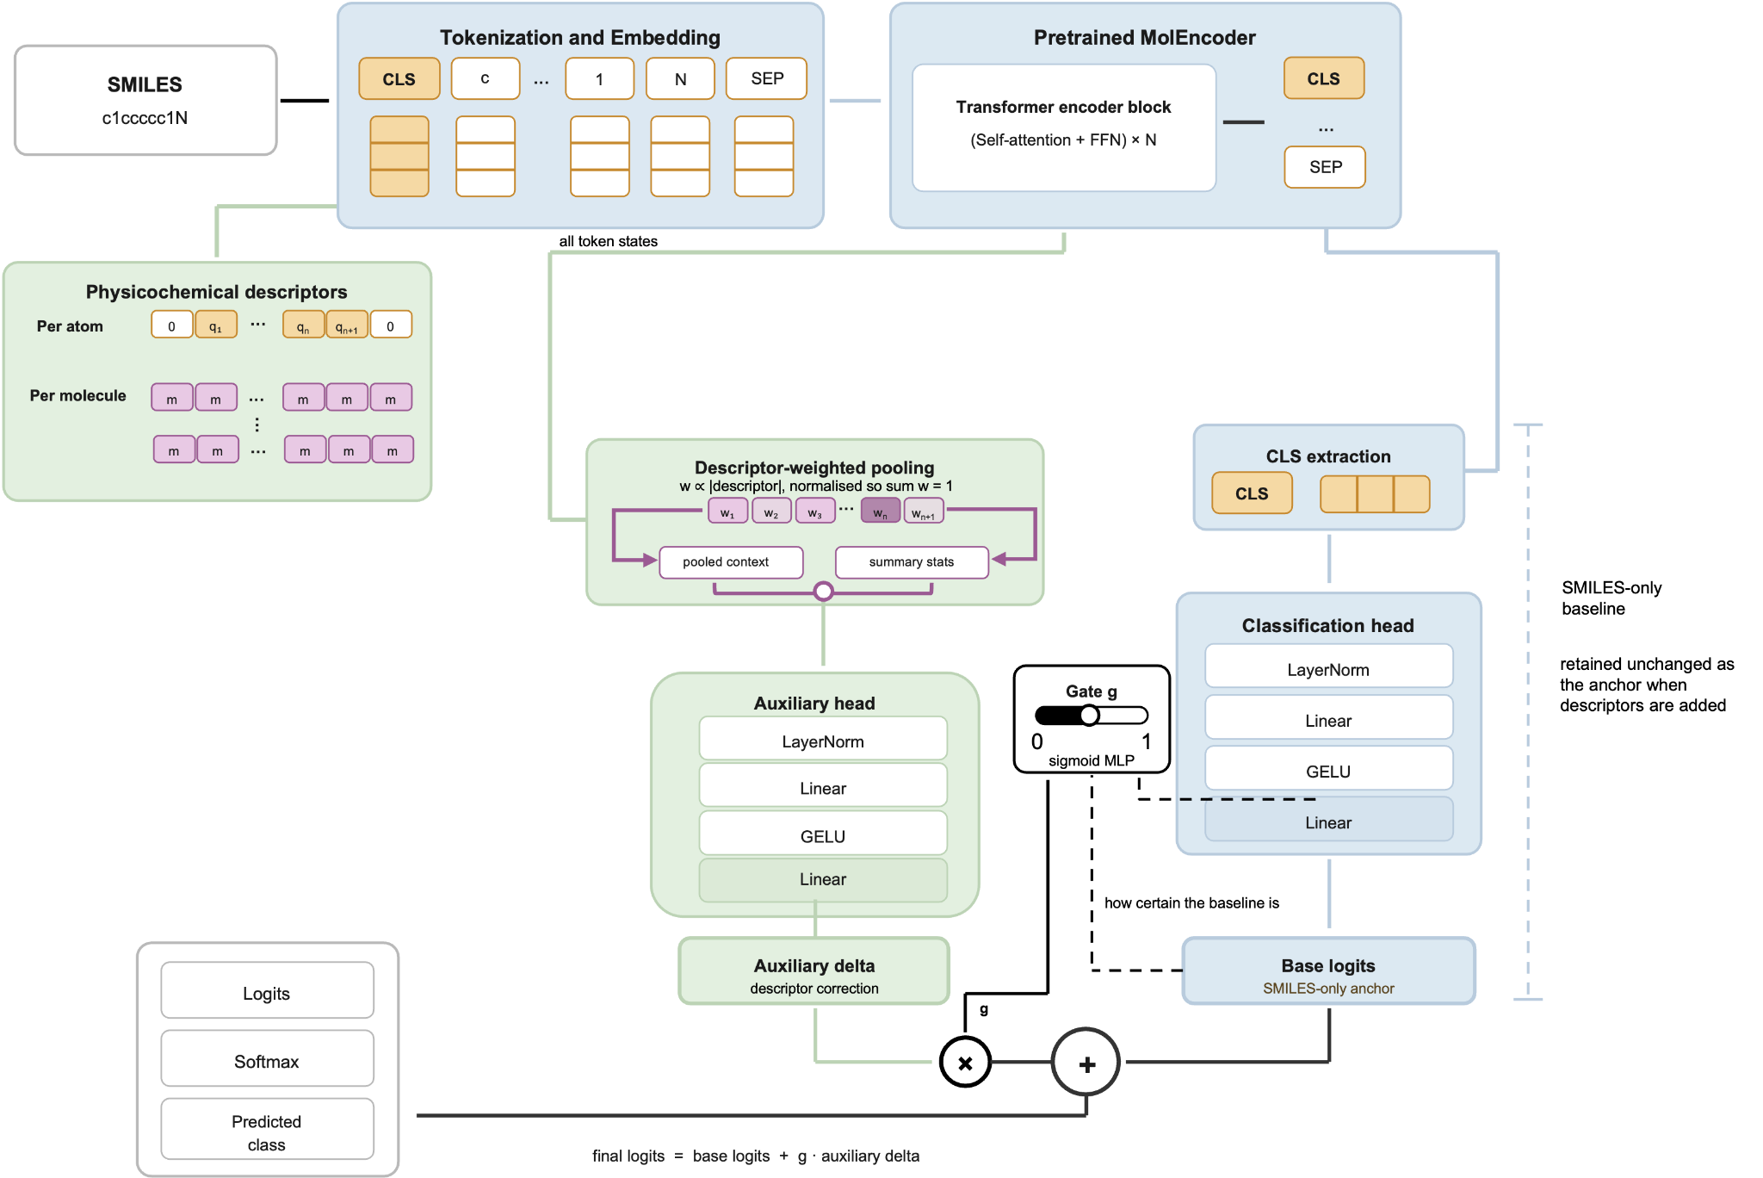

Figure 1. Confidence-gated descriptor correction to a retained SMILES-only baseline. SMILES strings are tokenized and encoded by MolEncoder. The CLS token feeds a classification head yielding the base logits, retained unchanged when descriptors are added. Descriptors are attached per token: atom-level values aligned to token positions, molecule-level values broadcast to every token. Token hidden states are pooled with descriptor-derived weights and passed through an auxiliary head to produce a correction term, which a gate scales according to the baseline's certainty before adding it to the base logits.

During fine-tuning, the pretrained MolEncoder weights were not kept frozen; instead, the full model, including both the encoder and the classification head, was optimized on the Ames and Pesticides and Genotoxicity Data datasets so that the molecular representation could adapt to the downstream toxicity prediction task.
Model training
For downstream training, the pretrained MolEncoder was fine-tuned on the Ames mutagenicity dataset for binary classification. Model performance was evaluated using stratified 5-fold cross-validation rather than a single fixed train/validation/test split. In each outer fold, one subset was held out as the test set, while the remaining data were used for training and validation. Within the training portion of each fold, a stratified validation split was generated for model selection and early stopping, corresponding to about 10% of the full dataset. The same random seed was used across experiments to ensure reproducibility and enable direct comparison between models. During fine-tuning, all model parameters, including both the pretrained encoder and the classification head, were updated jointly. Training was performed for up to 15 epochs using cross-entropy loss and the AdamW optimizer²⁵, while model performance on the validation set was monitored after each epoch. Early stopping based on validation loss (patience = 3, minimum improvement = 0.001) was used to select the optimal checkpoint within each fold. Under a single global learning rate the two pathways train under unequal conditions: the SMILES pathway is pretrained on a large dataset, while the descriptor pathway is randomly initialized and must therefore move much further from its starting point. The limitation is not the magnitude of the gradients reaching the fusion parameters, which we measured to be of the same order as, and typically several times larger than, those in the encoder pathway. It is the distance those parameters can travel. Because AdamW rescales each update by the running gradient magnitude, the displacement of a parameter over training is bounded by the learning rate multiplied by the number of optimizer steps; at 2 × 10⁻⁵ over the roughly 1,270 optimizer steps preceding the selected checkpoint, that bound is about 0.025 even if every step moved in the same direction. We verified this directly and the fusion weights remained close to their initialization. The descriptor pathway was therefore present but effectively unused. We consequently applied a separate learning rate of 2 × 10⁻³ to the fusion parameters, approximately two orders of magnitude above the encoder rate, so that both pathways train meaningfully within the same number of epochs. The residual gate was also initialized at zero bias (g = 0.5) rather than a negative bias of −2 (g = 0.12), which would start the descriptor contribution suppressed and, given the small gradients, leave it suppressed. Final performance was assessed on the outer test folds using balanced accuracy, receiver operating characteristic area under the curve (ROC AUC), sensitivity, specificity, precision, F1 score, accuracy and the confusion matrix. Balanced accuracy was calculated as (sensitivity + specificity) / 2 and was used as the primary accuracy-based metric to account for the unequal class distribution. Sensitivity and specificity were calculated as TP / (TP + FN) and TN / (TN + FP), respectively, where TP, TN, FP, and FN denote true positives, true negatives, false positives, and false negatives. Precision was defined as TP / (TP + FP), and the F1 score was calculated as 2 × (precision × sensitivity) / (precision + sensitivity). ROC AUC was used to evaluate the ranking performance of the classifier across decision thresholds. Performance values were reported as the mean across folds together with the standard deviation.

XAI methods
To interpret the trained models, integrated gradients (IG) was applied. IG computes feature attributions by integrating gradients along a path from a baseline input x′ to the actual input x, defined as:
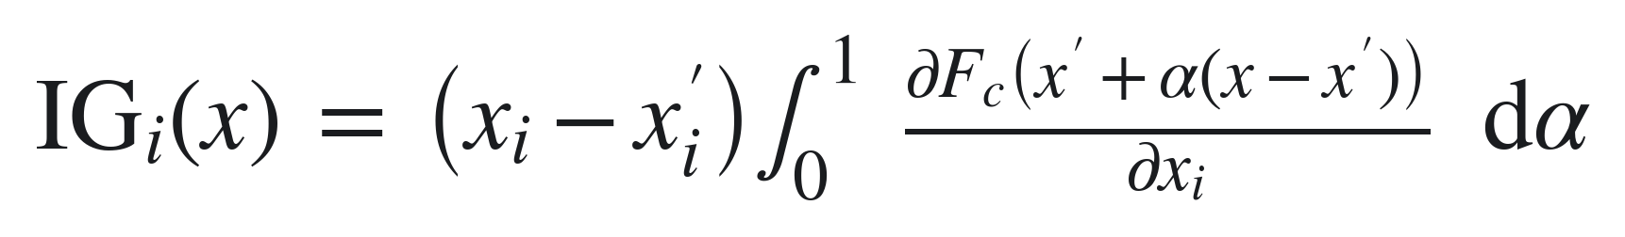
where F_{c} denotes the logit of the toxic class and α parameterises the path from the baseline to the input. The integral was approximated using the midpoint rule over 64 steps. Attributions were computed with respect to the token embeddings produced by the MolEncoder embedding layer, using the same tokenizer as during training, and with respect to the token-level descriptor channels. The baseline for token embeddings was the embedding of the tokenizer padding token, and the baseline for descriptor channels was the per-feature median over the training split of the corresponding fold. A median rather than a zero baseline was used for the descriptors because an all-zero charge vector does not correspond to a molecule that can exist, so integrating through it would measure extrapolation distance rather than importance. The first and last special tokens were excluded from interpretation and their scores were set to zero. Token-level attributions were mapped back onto atoms through the tokenizer character offsets; where a token spanned several characters its value was divided equally among them, and characters that encode bonds, branches or ring closures carry no corresponding atom and therefore do not appear in the atom-level maps. Integrated gradients satisfies the completeness axiom, which requires that the attributions sum to the difference between the model output at the input and at the baseline. This identity was evaluated for every molecule and used as a convergence check on the number of integration steps.

Because the architecture is additive at the output, the prediction being the sum of the SMILES-only logit and the gated descriptor correction, integrated gradients attributes the two pathways separately, and each attribution is an exact decomposition of its own contribution to the logit. In descriptor-augmented models, local token-level descriptors, such as partial charges, polarizability, or neighborhood features, were not passed into the pretrained MolEncoder transformer itself. Instead, MolEncoder processed only the SMILES token sequence and produced contextualized token hidden states, after which the local additional descriptors were incorporated in the downstream classifier through descriptor-weighted pooled context and descriptor summary statistics. The token-pathway attribution at a given position therefore reflects the SMILES token at that position, while the descriptor-pathway attribution reflects the local descriptor information associated with the same position. The per-atom values reported in this work are the sum of the two. This is consistent with the main aim of the XAI analysis: identification of influential molecular substructures and toxicophoric motifs.

Integrated gradients requires no perturbation of the input and no rebuilding of the molecule, so no atom is excluded from the analysis and every molecule contributes every one of its atoms. The attribution analysis reported here compares the SMILES-only baseline with the model augmented by per-atom Gasteiger charges, on both datasets. Configurations using molecule-level descriptors were not included in the attribution analysis, because such descriptors enter the model as a single value broadcast to every token position and are therefore not localized to any individual atom.

Molecular Preparation for Quantum Chemical Calculations
Protonation states were assigned to the CORINA-generated three-dimensional structures using LigPrep (Schrödinger Maestro version 14.6.125, Release 2025-4) with Epik²⁶. Ionization states were assigned at a target pH of 7.4 ± 0.2, consistent with physiological conditions. The OPLS4 force field²⁷ was used during structures preparation, because it provides a broadly validated parameterization for chemically diverse organic molecules, including charged species, and is therefore suitable for obtaining consistent starting geometries prior to downstream calculations. Original chiralities were retained, and additional stereoisomers were not exhaustively generated. Tautomer generation and desalting were not performed in Schrödinger LigPrep, because the Ames dataset was obtained from Therapeutics Data Commons²⁸ and cleaned beforehand. Preprocessing included RDKit parsing and sanitization, salt removal, exclusion of multi-fragment entries, canonicalization of SMILES strings, and removal of duplicates and conflicting labels. Existing stereochemical annotations were preserved when present, but missing or ambiguous stereochemistry was not reintroduced, since doing so would require unsupported assumptions about the true assayed stereoisomeric form. The output structures were saved in Maestro format for subsequent analysis.
A total of 7,255 molecules were processed with CORINA Classic (MN-AM)²⁹ for three-dimensional structure generation, all of which were successfully converted. Subsequent protonation state assignment with Epik at pH 7.4 ± 0.2 yielded 7,251 valid protonated structures, all of which were carried through the GFN2-xTB calculations described below.

Quantum Chemical Calculations
All protonated structures were subject to quantum mechanical refinement using GFN2-xTB³⁰ in ALPB implicit aqueous solvation³¹ as available from ULYSSES³². Electronic properties were estimated for each refined structure, including Gibbs free energies of solvation, vibrational frequencies, thermodynamic state functions (entropies, enthalpies, internal energies, heat capacities; between 250 and 350 K), partial charges and atomic polarizabilities.
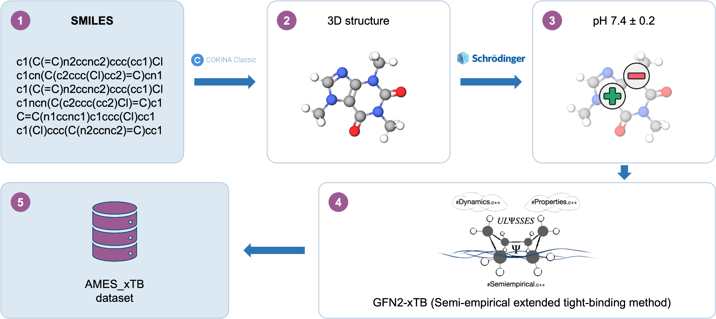
Figure 2. Workflow used to build the AMES_xTB dataset. (1) Input molecules are encoded as SMILES strings. (2) Three-dimensional structures are generated with CORINA Classic²⁹. (3) Protonation states are assigned at pH 7.4 ± 0.2 using Schrödinger³³. (4) Semiempirical single-point/optimization calculations are performed with the GFN2-xTB Hamiltonian as implemented in ULYSSES³². (5) The resulting structures and properties are compiled into the AMES_xTB dataset

The processed quantum-chemical descriptor dataset generated in this study is openly available (see the Availability of Data and Materials section).

Atom-to-Token Feature Mapping
Atomic partial charges were integrated into the SMILES-based representation used in the model. As the neural architecture operates on character-level tokens rather than atoms, a mapping procedure was implemented to align atom-wise charges with the corresponding SMILES tokens. For standard atoms, the computed charge was directly assigned to the corresponding token. In cases where atoms are represented by multiple characters (e.g., “Cl” or “Br”), the atomic charge was equally distributed across the associated tokens (e.g., split between “C” and “l”). For bracketed expressions (e.g., “[N+]”, “[O-]” or “[nH]” ), the charge was assigned to the first atomic symbol within the bracket, while all other characters, including brackets and charge indicators, were assigned zero. More generally, this reflects the fact that in the cleaned Ames SMILES used for modeling, hydrogens are represented almost exclusively in implicit form and therefore do not usually appear as separate tokens. The main explicit exception in the dataset was bracketed aromatic “[nH]” groups. Although hydrogen charges were present as separate atom-wise entries in the semiempirical output, these hydrogen entries were excluded before token-level mapping, and only heavy-atom charges were retained. Non-atomic symbols (e.g., digits, bond types, and special characters) were also assigned zero values. This procedure produced token-aligned charge vectors that were incorporated as an additional local descriptor channel in the downstream classifier, rather than in the MolEncoder input embeddings, thereby preserving compatibility with the pretrained SMILES-based encoder while allowing the model to incorporate atom-level physicochemical information. When a single token-level descriptor channel was used, its values entered the classifier unscaled. When several channels were combined, each was centred and divided by a fixed per-feature scale measured once across the dataset. This is necessary because the pooling weight is formed as the sum of the absolute descriptor values across channels: without it, molar refractivity (mean 3.24) and heavy-atom neighborhood counts (1.7–2.3) swamp partial charges (mean |q| 0.041) by a factor of 50 to 80 and alone determine which atoms receive weight. Partial charges were clipped to the interval from −2 to 2, and neighborhood counts were log-transformed, before scaling. Per-molecule normalization was found to be unsuitable: applied within a single molecule it removes absolute magnitude, which is precisely the quantity that distinguishes a reactive from a deactivated centre, and for molecule-level descriptors it normalizes quantities on unrelated scales against one another. Measured on 400 random molecules, the correlation between the raw value and the per-molecule normalized value across molecules was only 0.215 for the HOMO energy, and the sign of the chemical potential was inverted (r = −0.380). The same atom-to-token alignment procedure was also applied to the other local descriptor channels derived from semiempirical calculations.

Results
Ames mutagenicity is driven by relatively discrete toxicophores, and therefore the first experiment was designed to assess whether a pretrained molecular encoder could provide an effective representation for downstream toxicity prediction. In this setup, SMILES strings were encoded with the pretrained MolEncoder model, and a CLS-based classification head was fine-tuned on the Ames dataset. Model performance was evaluated using stratified 5-fold cross-validation. Under this setup, the baseline MolEncoder model achieved a mean ROC AUC of 0.857 ± 0.01 and a mean balanced accuracy of 0.776 ± 0.01. Detailed fold-wise results are provided in the Supporting Information.This baseline was used as a reproducible reference for subsequent experiments examining whether token-level physicochemical features improve predictive performance beyond the pretrained SMILES representation alone.

As a complementary comparison, a toxicity assignment derived from the OCHEM toxicophore screening export was also evaluated. OCHEM ToxAlerts tool³⁴ contains a set of toxicophores, i.e., structural alerts indicating that the compound likely has Ames toxicity, which were collected from literature (add references to respective articles). These alerts were created by the authors of the respective publications based on analysis of experimental data and their expert knowledge. For this study, the OCHEM screening results were exported as a tabular file containing per-molecule alert assignments across assay columns; this processed file is available in the project GitHub repository. For evaluation, each molecule was assigned an OCHEM-derived positive label when at least one assay column contained a value of 1, whereas molecules with only 0 or missing entries were treated as negative. Using the same stratified 5-fold partitioning scheme, the OCHEM-based assignment achieved a mean ROC AUC of 0.789 ± 0.01 and a mean balanced accuracy of 0.702 ± 0.01. These results indicate that explicit toxicophore-based evidence captures a substantial fraction of Ames-positive compounds, but with lower specificity than the fine-tuned MolEncoder baseline.
A key limitation of relying solely on structural alerts, such as the presence of an aromatic amine, is that the same fragment behaves differently depending on its electronic environment. An aromatic amine is a classical toxicophore associated with genotoxic carcinogenicity and mutagenicity, but conjugation and substituent effects render the aniline moiety electron-poor, reducing its ability to undergo metabolic activation. As a result, the nitrogen retains nucleophilic character rather than forming the electrophilic nitrenium ion typically implicated in DNA reactivity. Consequently, the expected toxicity mechanism is suppressed, despite the structural match to the alert. This illustrates why we decided to incorporate physicochemical properties into our analysis: structural motifs alone do not capture the electronic context that governs reactivity. By integrating descriptors that reflect electron density, conjugation, and overall molecular environment, we can better distinguish between truly reactive (electrophilic) aromatic amines and those that are electronically deactivated, thereby reducing false positives and improving the mechanistic relevance of our predictions.
Molecular (global) descriptors characterize the overall reactivity of a compound. The electrophilicity index (ω) provides a quantitative measure of a molecule’s tendency to accept electrons, with higher values indicating stronger electrophilic character and an increased potential for interaction with nucleophilic biological targets such as DNA. In predicting mutagenicity, the HOMO energy is particularly relevant, as it reflects the ionization potential and thus the ease with which a compound can be oxidized to form activated intermediates capable of electrophilic attack. The LUMO energy then determines the electron-accepting capacity of these activated species, allowing them to interact with nucleophilic targets. Consequently, the HOMO–LUMO gap alone is insufficient: a compound may be easily oxidized (low HOMO) but still lack the electron-accepting capacity to form reactive electrophilic species if the activated intermediate has an unfavorable LUMO. Together, HOMO energy and HOMO–LUMO gap provide critical information on both the activation barrier and the subsequent reactivity of the system. Larger gaps are associated with electronically stabilized, less reactive molecules, while smaller gaps indicate systems more prone to electronic excitation and chemical transformation. This dual perspective, combining ease of oxidation (HOMO) with the reactivity of activated forms (LUMO, HOMO–LUMO gap), allows us to distinguish between compounds that can form reactive species and those that are electronically deactivated, thereby reducing false positives in structure-based predictions.

Atomic (local) descriptors capture site-specific electronic effects that are critical for identifying reactive centers. These descriptors can be readily integrated into our pipeline, as attributions are computed at the token level, enabling direct mapping to specific atoms. Partial charge distributions can be obtained from semi-empirical (SE) quantum mechanical methods or density functional theory (DFT) calculations, providing detailed insight into electron density. Alternatively, Gasteiger charges³⁵, as implemented in RDKit, offers a computationally efficient approximation of charge distribution across the molecule.
Prior to the calculation of electronic descriptors, molecular structures were prepared as follows. CORINA Classic^{29,37,38} was used to generate three-dimensional structures from SMILES, providing a single low-energy conformation for each molecule. These geometries were subsequently used as input for protonation state assignment with Schrödinger LigPrep/Epik³³ at pH 7.4 ± 0.2.

The relevance of these electronic descriptors must be considered in the context of the biological conditions under which toxicity is assessed. The Ames test is performed in an aqueous environment at approximately neutral pH (≈ 7.0–7.4)³⁹, where the protonation state of ionizable groups is determined by their pKa. As protonation directly affects electron distribution, it can significantly influence orbital energies and charge-related descriptors, thereby altering predicted reactivity. In this work, protonation states were assigned at pH 7.4 ± 0.2 using Schrödinger Epik³³, which predicts pKa values and generates the most probable ionization states under specified conditions.

To investigate whether chemically interpretable descriptors could complement the pretrained SMILES representation, several groups of local and global molecular features were added to the classifier. Local atom-level descriptors were aligned with SMILES tokens and included Gasteiger partial charges, semiempirical Mulliken charges, atomic polarizabilities, and heavy-atom neighborhood counts. Gasteiger charges were calculated using RDKit, whereas semiempirical charges and polarizabilities were extracted from ULYSSES³² semiempirical calculation. Heavy-atom neighborhood descriptors were calculated as the number of non-hydrogen atoms within graph distances of two, three, and four bonds from each atom, providing information about the local substituent environment. Global molecule-level descriptors included RDKit physicochemical properties, such as molecular weight, topological polar surface area, LogP, molar refractivity, hydrogen-bond donor and acceptor counts, rotatable bond count, ring count, heavy atom count, and fraction of sp³ carbons. In addition, semiempirical orbital descriptors were extracted from the same calculation files: the HOMO energy, the LUMO energy, and the electrophilicity index. The remaining quantities available from the calculation (HOMO-LUMO gap, chemical potential and hardness) are algebraic functions of the frontier orbital energies and were omitted as redundant. Molecule-level descriptors were not passed through a separate fusion branch. Each global value was instead broadcast to every token position, so that global and per-atom descriptors enter the classifier through the same pathway.

The performance of all tested feature combinations is summarised in Table 1. Every descriptor set attached at the token level improved on the SMILES-only baseline of 0.857 ± 0.01. Gasteiger partial charges raised ROC AUC to 0.875 ± 0.01 (p = 0.017, improving in all 5 folds), demonstrating that the improvement is statistically significant. xTB-calculated Mulliken charges achieved nearly identical results and did not significantly outperform the simpler RDKit charges. This suggests that descriptor accuracy is less important than the underlying chemical relationships, the model learns to exploit differences in atomic charge, whether computed quantum-mechanically or empirically, particularly when atoms are proximal or conjugated. In an earlier version of the dataset, compounds for which xTB values could not be calculated were retained and their charges filled with RDKit values instead. Accuracy dropped below the baseline, and the comparison between semi-empirical and empirical charges was contaminated. Every compound in the present work carries a genuine calculation and no substitute values are used anywhere. This reinforces the point above: what matters is not how accurate the charges are, but how consistently they relate to one another across the dataset, since a channel that mixes two sources of charge breaks the relationship the model learns from it. Polarizability descriptors (xTB and RDKit molar refractivity) showed modest improvements that did not reach statistical significance, indicating they are individually insufficient for the prediction task. The two molecule-level descriptor sets, broadcast per token, improved performance more robustly: orbital descriptors reached 0.870 ± 0.01 and RDKit physicochemical properties 0.874 ± 0.02, both improving in all five folds. xTB orbital descriptors showed the lowest fold-to-fold variance, making them the most reproducible result despite their modest effect size. Combining descriptor sets yielded no additional benefit. We tested different fusion techniques and weighting schemes, but results remained consistent, suggesting that single descriptors capture the maximum learnable chemical signal available in this dataset.

To test whether these improvements generalize to a larger and chemically broader dataset, we applied the same protocol to nearly 20,000 compounds from the Pesticides Genotoxicity dataset (compared to ~7,000 from Ames), excluding only runs requiring xTB-calculated properties, specifically Mulliken charges, polarizability, and orbital descriptors. These calculations are computationally expensive and showed no improvement over RDKit empirical descriptors on the Ames set. Excluding them enables deployment on new datasets without expensive quantum-chemical preprocessing, simple SMILES-and-labels inputs can generate predictions with chemical explanations on the fly. We applied the same architecture, five-fold stratified cross-validation protocol, and random seed to test whether physicochemical properties maintain their accuracy and explainability benefits. On pesticides, Gasteiger charges alone did not reach statistical significance (p = 0.17), but heavy-atom neighborhoods and RDKit global descriptors remained significant. Effect sizes were smaller than on Ames but directional gains were consistent. RDKit physicochemical properties again showed the lowest fold-to-fold variance, and combined descriptors provided no additional benefit over individual ones. These results confirm that descriptor-augmented token embeddings generalize across chemical domains and toxicological endpoints.

Table 1. Performance of MolEncoder-based models and descriptor-augmented variants on the Ames dataset, reported as the mean across five stratified cross-validation folds with the standard deviation. Sorted by ROC AUC.

Model / feature set | ROC AUC | Balanced accuracy
OCHEM-derived toxicophore assignment | 0.789 ± 0.01 | 0.702 ± 0.01
MolEncoder baseline, SMILES only | 0.857 ± 0.01 | 0.776 ± 0.01
SMILES + polarizability (RDKit)* | 0.865 ± 0.02 | 0.789 ± 0.02
SMILES + polarizability (xTB) | 0.866 ± 0.02 | 0.791 ± 0.01
SMILES + charges (RDKit) + neighborhoods + polarisability (RDKit) | 0.870 ± 0.01 | 0.788 ± 0.01
SMILES + orbital descriptors (xTB) | 0.870 ± 0.01 | 0.792 ± 0.01
SMILES + neighborhoods | 0.870 ± 0.01 | 0.795 ± 0.01
SMILES + charges (xTB)* | 0.874 ± 0.01 | 0.793 ± 0.01
SMILES + global descriptors (RDKit) | 0.874 ± 0.02 | 0.798 ± 0.02
SMILES + charges (RDKit)* | 0.875 ± 0.01 | 0.789 ± 0.01
SMILES + charges (RDKit) + neighborhoods | 0.876 ± 0.01 | 0.791 ± 0.02

* RDKit polarizability is Crippen molar refractivity; RDKit charges are Gasteiger charges. xTB charges are Mulliken charges.
As representative qualitative examples, three Ames-positive test-set molecules were selected for integrated-gradients attribution (Figure 3). All three belong to the cohort of 600 test-set compounds whose prediction changed from incorrect to correct when per-atom Gasteiger charges were added, so they isolate what the descriptors contribute: each was classified as non-toxic by the SMILES-only MolEncoder baseline and as toxic by the descriptor-augmented model. They span three distinct mechanisms, a directly electrophilic epoxide, an aromatic nitro compound that requires metabolic activation, and a Michael acceptor. Together, these examples suggest that the added physicochemical and local-environment descriptors improved not only predictive performance but also the chemical specificity of the model explanations.

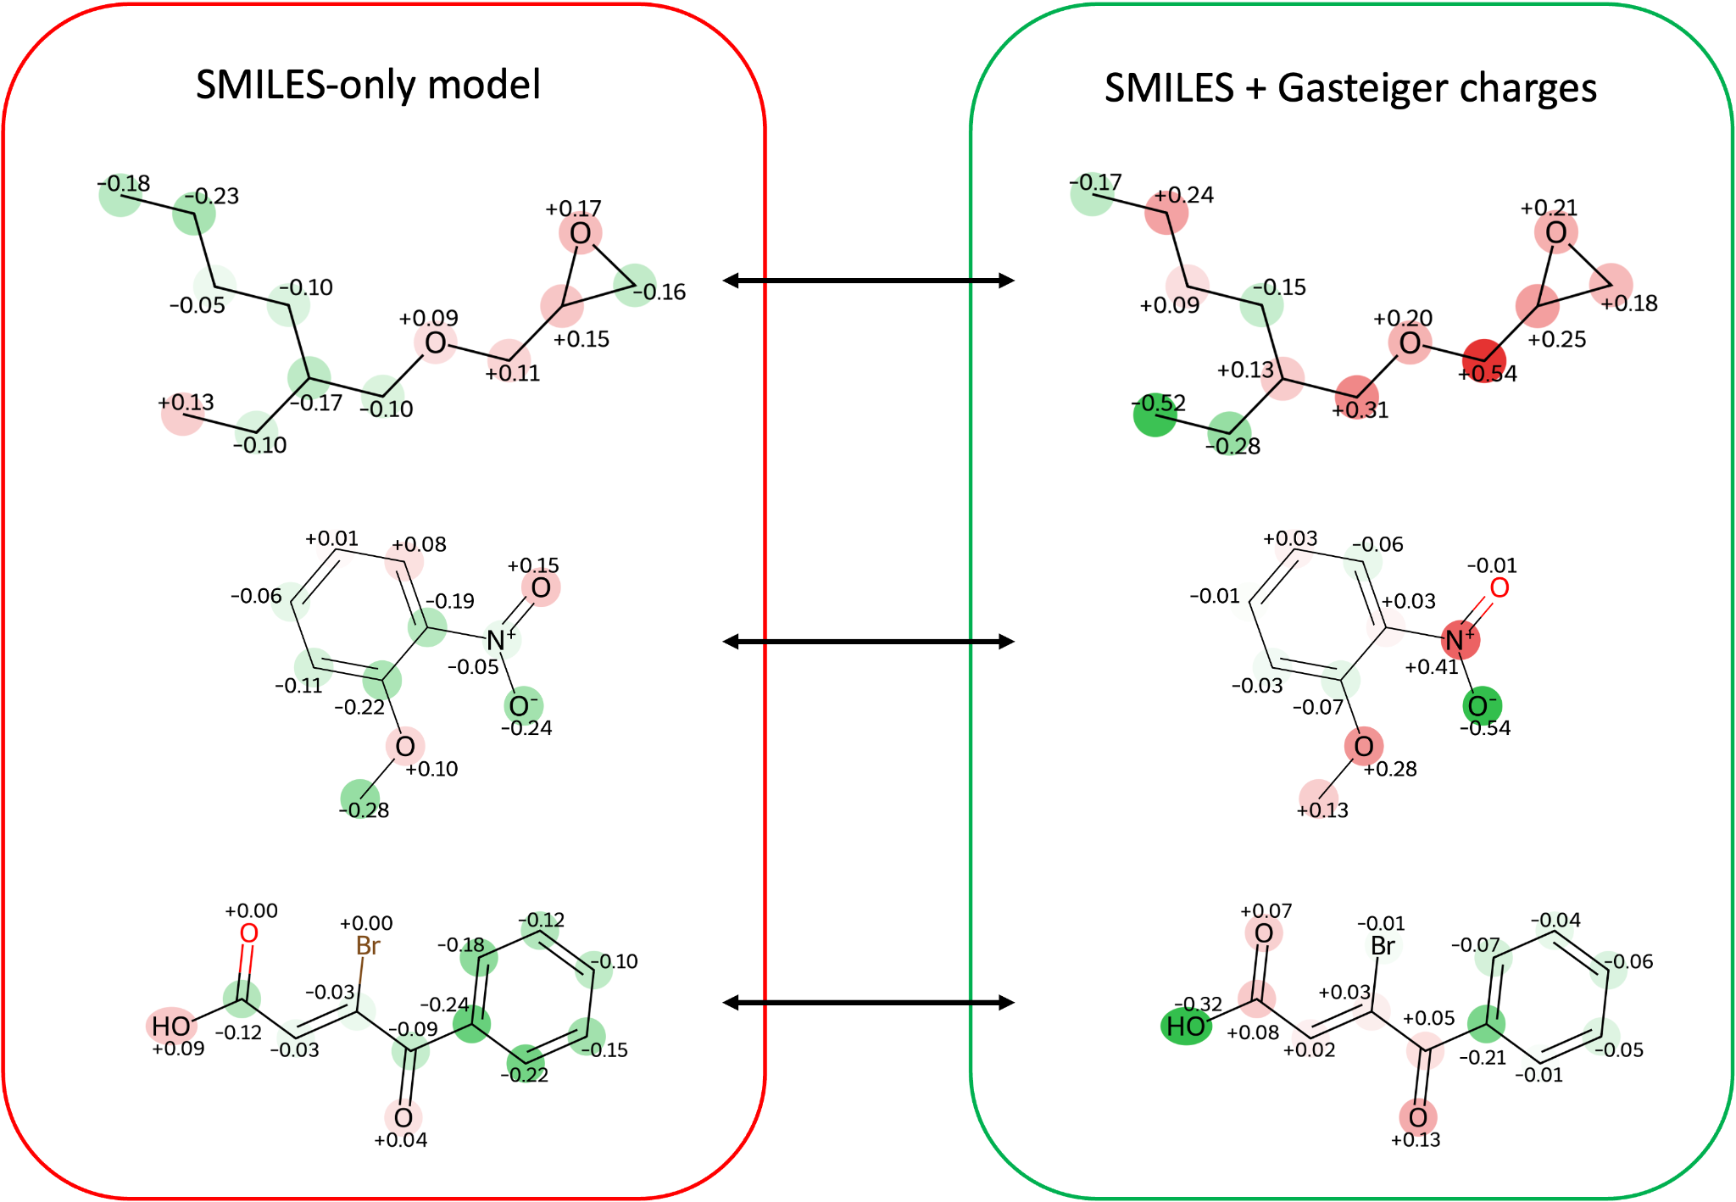

Figure 3. Integrated-gradients attributions before and after adding per-atom Gasteiger charges. Left: SMILES-only model. Right: model with charge descriptors. Rows: 2-ethylhexyl glycidyl ether (epoxide), 2-nitroanisole (aromatic nitro), and 3-bromo-4-oxo-4-phenylbut-2-enoic acid (Michael acceptor). Values are signed per-atom contributions to the logit difference from an all-padding baseline, where red indicates a contribution toward mutagenicity, green away from it. In each case the SMILES-only model misclassifies the compound and the charge-augmented model classifies it correctly.

The examples presented in Figure 3 show how adding physicochemical properties helps the model get closer to chemical intuition and known mechanism, rather than relying on repeated patterns without taking the environment into account. The same fragment can be active or inactive depending on the conjugated system that withdraws electron density, or on how sterically hindered the atom is. Let us look at the first molecule, 2-ethylhexyl glycidyl ether. The reaction proceeds by an SN2 mechanism at the less hindered carbon of the ring. The SMILES-only model does not capture this: the attribution on that atom is −0.16, meaning the post-hoc XAI does not treat it as contributing towards mutagenicity. The descriptor model, on the other hand, correctly highlights this atom in red (+0.18). The other two ring atoms increase their values towards toxicity as well. In contrast, the terminal carbon of the ethyl branch goes from +0.13 to −0.52. So the model does not simply shift all attributions towards mutagenicity, it correctly identifies flips both towards and against toxicity. Unlike the epoxide, 2-nitroanisole is not electrophilic as drawn and requires metabolic activation: nitroreduction at the nitro nitrogen ultimately yields a nitrenium ion that reacts with guanine in DNA. The SMILES-only model leaves that nitrogen essentially neutral (−0.05), treating the alert as a pattern rather than a reactive centre. With Gasteiger charges it becomes the dominant positive atom (+0.41), and the prediction flips to correct. The last compound carries an Ames toxicophore: a Michael acceptor, with the C=C conjugated to both a carboxylic acid and a phenyl ketone. The SMILES-only model gives no meaningful positive attribution to the conjugated system, the largest being +0.05 on the ketone oxygen, and assigns its strongest positive attribution instead to the hydroxyl group (+0.09). With charges, positive attribution moves onto the atoms forming the Michael acceptor, and is larger on the ketone oxygen (+0.13) than on the carboxylic acid oxygen (+0.07), while the hydroxyl turns negative (−0.32). This ordering matches the chemistry: the ketone carbonyl withdraws electron density more strongly than the acid carbonyl, which is itself deactivated by donation from the hydroxyl. Stronger withdrawal leaves the β-carbon more electron-poor and the Michael acceptor more reactive.

The three examples above are individual cases, so we tested whether the same behaviour holds across the dataset. Because the architecture is additive at the output, the descriptor pathway's contribution to a prediction is exactly the gated auxiliary term, and it can therefore be read directly for all 7,251 compounds, without an attribution method and without perturbing the input. Compounds were grouped by the structural alerts they carry, using the Kazius alert set, and within each alert the mutagenic compounds were compared with the non-mutagenic ones. This cut depends only on the experimental label and on substructure membership, not on model behaviour, so the comparison is not circular. Across all 4,026 alert-bearing compounds, the mean descriptor contribution was +1.53 for the mutagenic ones and 0.00 for the non-mutagenic ones. In all nine alerts carrying at least ten compounds in each class, the descriptor contribution was significantly higher for the mutagenic compounds. For the epoxide alert the mean contribution was +2.38 for mutagenic compounds against −0.43 for non-mutagenic ones (n = 330 and 103, p = 2 × 10⁻³⁴); for the aromatic nitro alert, +2.19 against +0.44 (n = 822 and 133, p = 5 × 10⁻³¹); and for the aromatic amine alert, +1.26 against −0.21 (n = 486 and 140, p = 1 × 10⁻²²). The descriptor pathway therefore does not merely reinforce the presence of an alert, which would raise the score for every compound carrying it, but separates compounds in which the alert is electronically activated from those in which it is not. This is the same behaviour the three examples show individually, measured over the whole dataset. The complete set of alerts is given in Table S1 of the Supporting Information.

Table 2. Performance of MolEncoder-based models and descriptor-augmented variants on the Pesticides and Genotoxicity Data dataset, reported as the mean across five stratified cross-validation folds with the standard deviation. Sorted by ROC AUC.

Model / feature set | ROC AUC | Balanced accuracy
OCHEM-derived toxicophore assignment | 0.772 ± 0.01 | 0.691 ± 0.01
MolEncoder baseline, SMILES only | 0.870 ± 0.01 | 0.795 ± 0.01
SMILES + charges (RDKit)* | 0.878 ± 0.01 | 0.799 ± 0.02
SMILES + neighborhoods | 0.880 ± 0.01 | 0.807 ± 0.01
SMILES + charges (RDKit) + neighborhoods | 0.881 ± 0.01 | 0.808 ± 0.01
SMILES + global descriptors (RDKit) | 0.882 ± 0.01 | 0.809 ± 0.01

* RDKit charges are Gasteiger charges
We observe the same tendency in the pesticide results, but the increase is smaller. Two factors contribute: the larger dataset and the stronger baseline. The SMILES-only model is already more accurate here from the start, so the same descriptors have less room to improve it. Combining charges with neighbourhood counts again gives no further gain over the better single descriptor set: adding physicochemical information helps, but the benefit saturates.

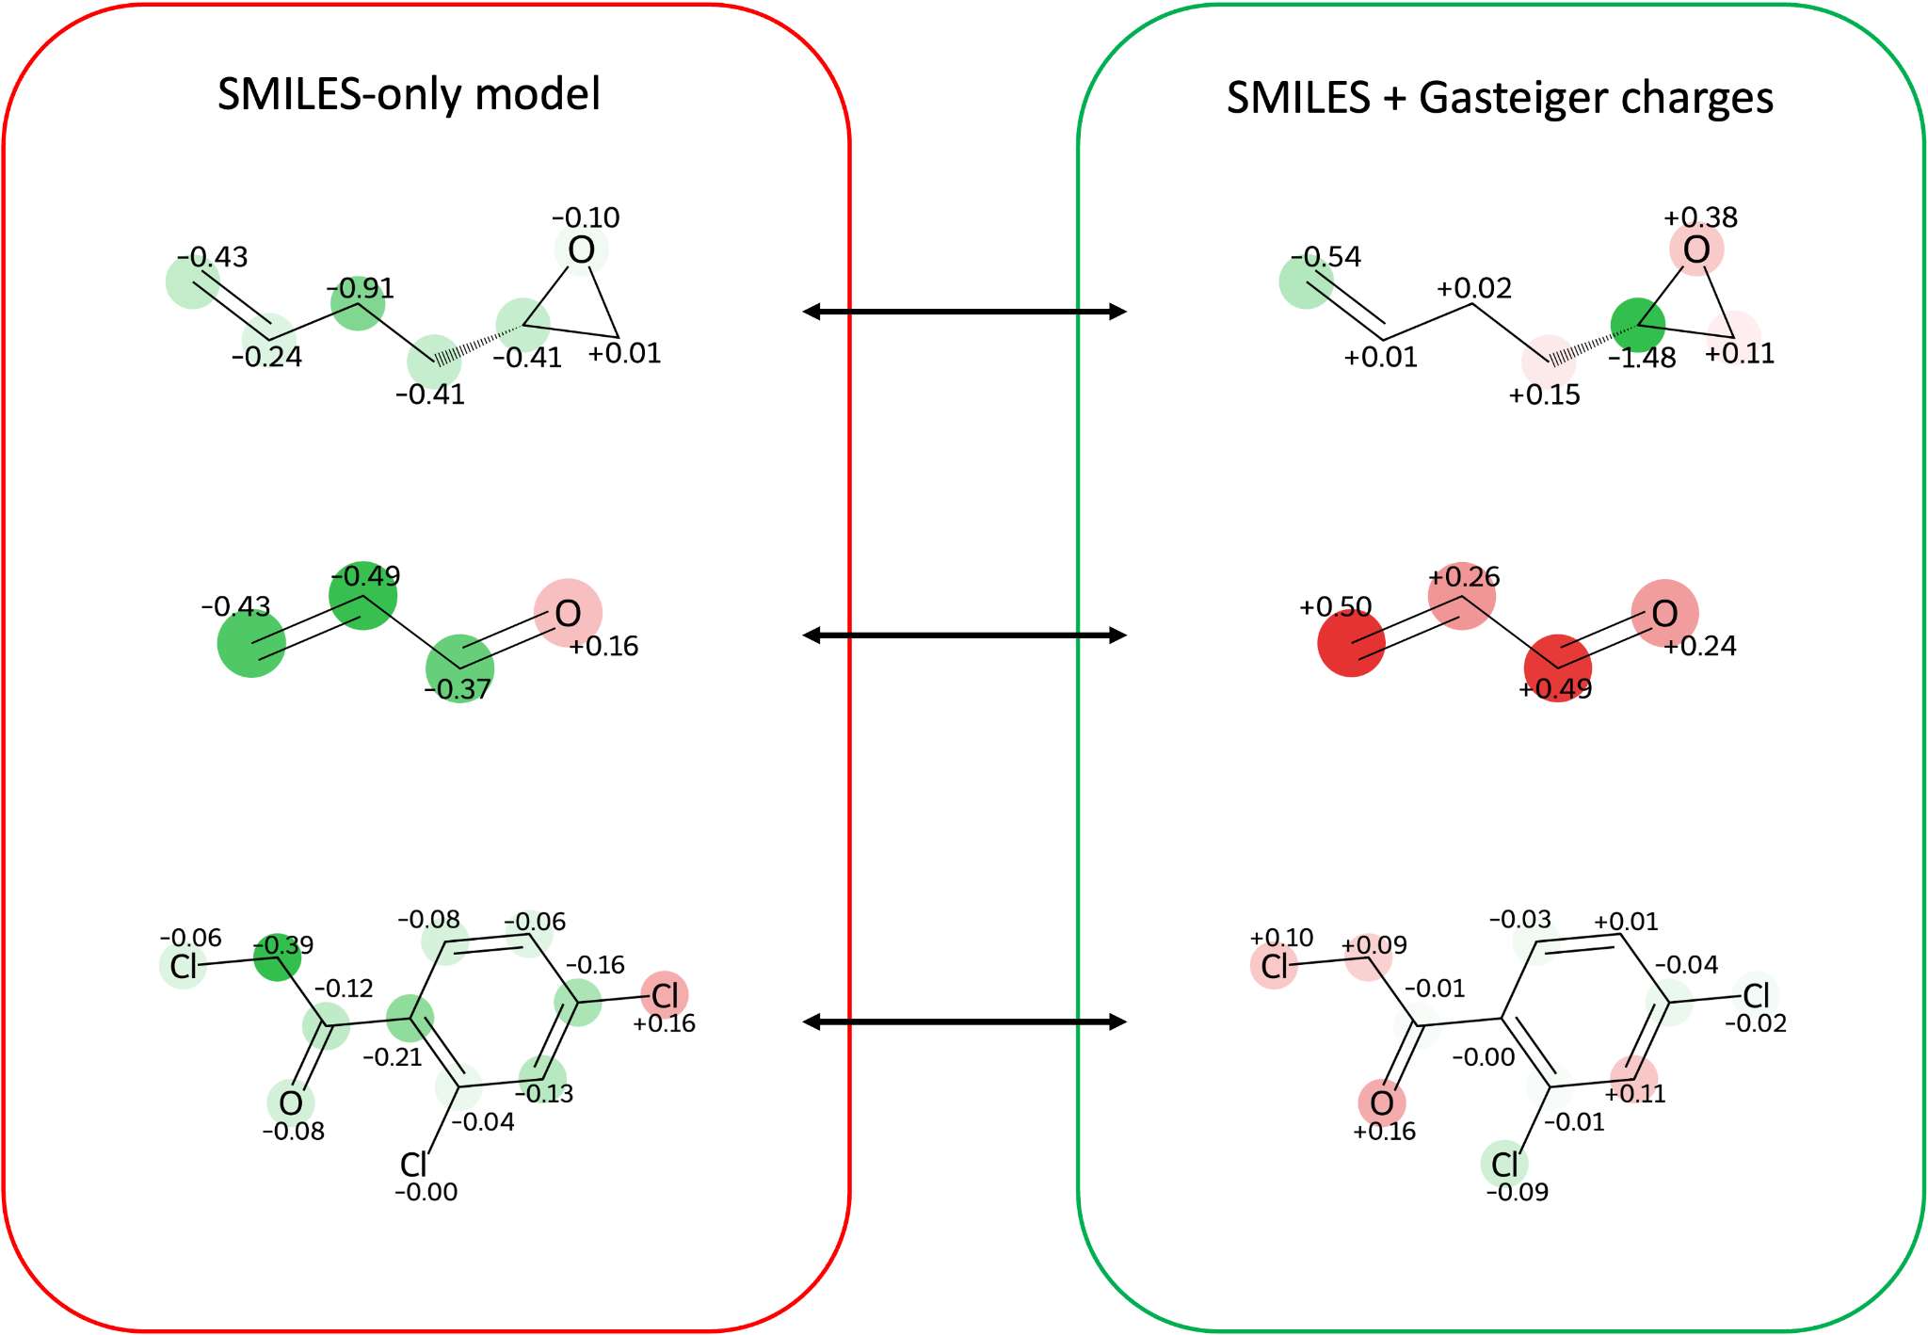

Figure 4. Integrated-gradients attributions before and after adding per-atom Gasteiger charges, for the pesticide genotoxicity dataset. Left: SMILES-only model. Right: model with charge descriptors. Rows: 1,2-epoxy-5-hexene (epoxide), acrolein (α,β-unsaturated aldehyde), and 2-chloro-1-(2,4-dichlorophenyl)ethanone (α-halo ketone). Values are signed per-atom contributions to the logit difference from an all-padding baseline, where red indicates a contribution toward mutagenicity, green away from it. In each case the SMILES-only model misclassifies the compound and the charge-augmented model classifies it correctly.
The same behaviour appears on the pesticide set, which uses the same Ames endpoint. The first row, 1,2-epoxy-5-hexene, repeats the logic of the epoxide case: the SMILES-only model places its largest weight away from the reactive site, assigning −0.41 to the ring carbon and −0.91 to a chain carbon far from the ring. With charges, the epoxide oxygen and the less hindered ring carbon, the site of SN2 attack, both turn positive (+0.38 and +0.11), while the terminal alkene falls to −0.54. As in the Ames epoxide, positive attribution concentrates on the site of attack rather than elsewhere in the molecule, while the more substituted ring carbon, which is not the site of SN2 attack, becomes the most strongly negative atom (−1.49). Acrolein is the minimal Michael acceptor, and the same reasoning applies as for the α,β-unsaturated system in Figure 3: withdrawal by the carbonyl leaves the β-carbon electron-poor and open to conjugate addition. The SMILES-only model marks the entire conjugated system as arguing against mutagenicity (−0.43, −0.49, −0.37). With charges all three heavy atoms of the system invert sign (+0.50, +0.26, +0.49) together with the carbonyl oxygen (+0.24). The third-row molecule contains three C–Cl bonds, of which only one is reactive. Those attached to the aryl ring are not accessible to an SN2 mechanism, since conjugation of the chlorine lone pairs with the ring gives these C–Cl bonds partial double-bond character. The SMILES-only model highlights one of the aryl chlorides instead (+0.16) and places negative attribution on the α-chloro carbon (−0.39). With charges the ordering reverses: the α-chloro carbon and its chlorine become positive (+0.09, +0.10) along with the carbonyl oxygen (+0.16), while the two aryl chlorides turn negative (−0.02, −0.09). Resolving the same atom (halogen) in different electronic environments brings the extended model closer to the reasoning a chemist would apply.

Discussion
Descriptors are combined with the learned representation after the encoder rather than at its input. The transformer receives the SMILES token sequence alone; the descriptors then weight the pooling of its output token states and feed an auxiliary head whose correction is added to the SMILES-only logit through a confidence gate. Two design choices follow from this. First, the descriptor pathway reads contextualized token representations rather than a single pooled vector, so it retains positional information that a strategy attaching descriptors only at classification time discards. Second, the SMILES-only prediction is preserved exactly as an anchor, so adding descriptors can only act as a correction to it and the contribution of the descriptors is recoverable for every molecule as the gated auxiliary term. Injecting descriptors into the token embeddings before the encoder was also tested and abandoned: starting from a zero-initialized injection, the projection weights reached only about 0.1% of the token-embedding magnitude over the training budget, so the descriptors were present but too small to carry information. The route by which molecule-level descriptors enter matters as much as whether they are used at all. Passing them through a separate fusion branch with per-molecule normalization reduced ROC AUC below the SMILES-only baseline, to 0.845 for the orbital descriptors and 0.851 for the RDKit physicochemical set against a baseline of 0.857. Broadcasting the same values to every token position and standardizing them per feature across the dataset reversed the sign of both results, to 0.870 and 0.874.

A limitation of the present architecture is that the final prediction is based on the pooled hidden representation of the CLS token rather than directly on atom-level outputs. As a result, chemically relevant information is first integrated across the full SMILES sequence through multiple self-attention layers and only then compressed into a single global molecular representation for classification. Consequently, integrated gradients reflect the contribution of individual token embeddings and descriptor channels to the final pooled decision, rather than a purely local atom-to-output relationship. Each character is a separate token, so a token's attribution goes to the atom that character belongs to; characters that encode bonds, branches or ring closures have no corresponding atom, so their attribution does not appear in the atom-level figures. This can make the interpretation less sharply localized, since the influence of a toxicophore may be distributed across several tokens and their surrounding context. Nevertheless, the method remains informative for identifying which parts of the sequence most strongly affect the final toxicity prediction.

Two further limitations concern the fusion mechanism itself. The gate is conditioned only on the confidence and margin of the SMILES-only prediction, not on the content of the descriptors, and in practice it varies little: across the 7,251 Ames compounds it has a mean of 0.25 and a standard deviation of 0.06, and its mean differs by less than 0.003 between the compounds whose prediction the descriptors correct and those whose prediction they damage. The magnitude of a descriptor correction is therefore set almost entirely by the auxiliary head rather than by the gate, and the gate cannot learn to suppress a descriptor set that carries no information. In addition, when several descriptor groups are supplied together, their auxiliary representations are averaged before fusion, which gives an uninformative group the same weight as an informative one. This offers one explanation for the observation that combining descriptor sets produced no gain over the best single set on either dataset.

Conclusion

We augmented a pretrained SMILES-based molecular language model with physicochemical descriptors through a confidence-gated residual fusion, and evaluated the result on two mutagenicity datasets under an identical five-fold cross-validation protocol. Every descriptor set attached at the token level improved on the SMILES-only baseline, with Gasteiger partial charges raising ROC AUC from 0.857 to 0.875 on the Ames benchmark and RDKit physicochemical properties reaching 0.874. The same direction of improvement was reproduced on 18,754 pesticide compounds, with smaller effect sizes against a stronger baseline. Semi-empirical descriptors conferred no measurable advantage over empirical ones: GFN2-xTB Mulliken charges were statistically indistinguishable from Gasteiger charges despite several orders of magnitude more computation, and combining descriptor sets gave no further gain over the best single set. The practical consequence is that the benefit reported here is available from descriptors computable directly from SMILES, without quantum-chemical preprocessing.

Beyond predictive accuracy, the basis of the explanations changed. With charges added, integrated-gradients attributions moved onto the atoms that carry the accepted mechanism, the less hindered carbon of an epoxide, the nitrogen of an aromatic nitro group, the conjugated system of a Michael acceptor, and away from inert parts of the molecule. This is not confined to individual examples: across the 4,026 alert-bearing Ames compounds, the descriptor pathway separated mutagenic from non-mutagenic compounds carrying the same structural alert, in every one of the nine alerts with sufficient support. Physicochemical augmentation therefore does more than improve predictions; it shifts the basis of the explanation from the presence of a substructure to the electronic context in which that substructure sits, which is the form of evidence a toxicologist can act on.

Declarations
Availability of data and materials
Smarts of functional groups are provided in Supplementary Information and code for the models and databases, together with the data used in this study, is available on GitHub and GitLab: https://github.com/DinaKhasanova/xai_dft and https://gitlab.com/DinaKhasanova/xai_dft. The processed quantum-chemical descriptor dataset generated in this study is openly available at Zenodo (DOI/link) as two linked tables: a molecule-level table containing original and canonical SMILES together with global descriptors, and a token-level table containing the MolEncoder tokenized SMILES representation with mapped local descriptor values for each token.

Competing interests
Several authors (C.H.S., O.S., T.M.) are employed by Molecular Networks GmbH Altamira LLC (MN-AM), a company with commercial interests in cheminformatics software, including CORINA Classic, which was used in this study. The remaining authors declare no competing interests.

Funding
This work was partially funded by the Horizon Europe funding programme under the Marie
Sklodowska-Curie Actions Doctoral Networks grant agreement “Explainable AI for Molecules – AiChemist”, no. 101120466.

Authors’ contributions
Dina Khasanova: conceptualization, methodology, software, validation, formal analysis, investigation, data curation, writing – original draft, writing – review & editing, visualization. Igor Tetko: conceptualization, writing – review & editing, supervision, project administration, funding acquisition. Filipe Menezes: methodology, software, data curation, writing – review & editing. Federico Ballabio: software, data curation, writing – review & editing. Christof H. Schwab: software, conceptualization, writing – review & editing, supervision. Oliver Sacher: conceptualization, writing – review & editing, supervision. Tomasz Magdziarz: conceptualization, writing – review & editing, supervision. Chris Barber: writing – review & editing, project administration, funding acquisition.

Acknowledgments
We thank the members of the Structural Biology (STB) department at Helmholtz Munich for their helpful discussions and valuable feedback that improved this work.

Declaration of AI assistance

Claude Code (Anthropic, using Claude Opus and Claude Sonnet) was used to assist with phrasing in this manuscript and with writing and refactoring code. All text, code and reported results were reviewed and verified by the authors, who take full responsibility for the content of this work.

References
(1) Kola, I.; Landis, J. Can the Pharmaceutical Industry Reduce Attrition Rates? Nature reviews Drug discovery 2004, 3 (8), 711–716.
(2) Waring, M. J.; Arrowsmith, J.; Leach, A. R.; Leeson, P. D.; Mandrell, S.; Owen, R. M.; Pairaudeau, G.; Pennie, W. D.; Pickett, S. D.; Wang, J. An Analysis of the Attrition of Drug Candidates from Four Major Pharmaceutical Companies. Nature reviews Drug discovery 2015, 14 (7), 475–486.
(3) Ames, B. N.; McCann, J.; Yamasaki, E. Methods for Detecting Carcinogens and Mutagens with the Salmonella/Mammalian-Microsome Mutagenicity Test. Mutat. Res.;(Netherlands) 1975, 31.
(4) Mansouri, K.; Abdelaziz, A.; Rybacka, A.; Roncaglioni, A.; Tropsha, A.; Varnek, A.; Zakharov, A.; Worth, A.; Richard, A. M.; Grulke, C. M. CERAPP: Collaborative Estrogen Receptor Activity Prediction Project. Environmental health perspectives 2016, 124 (7), 1023.
(5) Yang, K.; Swanson, K.; Jin, W.; Coley, C.; Eiden, P.; Gao, H.; Guzman-Perez, A.; Hopper, T.; Kelley, B.; Mathea, M. Analyzing Learned Molecular Representations for Property Prediction. Journal of chemical information and modeling 2019, 59 (8), 3370–3388.
(6) Oecd, D. Guidance Document on the Validation of (Quantitative) Structure-Activity Relationship [(Q) SAR] Models. Organ. Econ. Co-operation Dev. Paris Fr 2007.
(7) Jiménez-Luna, J.; Grisoni, F.; Schneider, G. Drug Discovery with Explainable Artificial Intelligence. Nature Machine Intelligence 2020, 2 (10), 573–584. https://doi.org/10.1038/s42256-020-00236-4
(8) Honda, S.; Shi, S.; Ueda, H. R. Smiles Transformer: Pre-Trained Molecular Fingerprint for Low Data Drug Discovery. arXiv preprint arXiv:1911.04738 2019.
(9) Chithrananda, S.; Grand, G.; Ramsundar, B. ChemBERTa: Large-Scale Self-Supervised Pretraining for Molecular Property Prediction. arXiv preprint arXiv:2010.09885 2020.
(10) Fabian, B.; Edlich, T.; Gaspar, H.; Segler, M.; Meyers, J.; Fiscato, M.; Ahmed, M. Molecular Representation Learning with Language Models and Domain-Relevant Auxiliary Tasks. arXiv preprint arXiv:2011.13230 2020.
(11) Ross, J.; Belgodere, B.; Chenthamarakshan, V.; Padhi, I.; Mroueh, Y.; Das, P. Large-Scale Chemical Language Representations Capture Molecular Structure and Properties. Nature Machine Intelligence 2022, 4 (12), 1256–1264.
(12) Honma, M. An Assessment of Mutagenicity of Chemical Substances by (Quantitative) Structure–Activity Relationship. Genes and Environment 2020, 42 (1), 23.
(13) Truchon, J.-F.; Bayly, C. I. Evaluating Virtual Screening Methods: Good and Bad Metrics for the “Early Recognition” Problem. Journal of chemical information and modeling 2007, 47 (2), 488–508.
(14) Ahmad, W.; Simon, E.; Chithrananda, S.; Grand, G.; Ramsundar, B. Chemberta-2: Towards Chemical Foundation Models. arXiv preprint arXiv:2209.01712 2022.
(15) Moriwaki, H.; Tian, Y.-S.; Kawashita, N.; Takagi, T. Mordred: A Molecular Descriptor Calculator. Journal of cheminformatics 2018, 10 (1), 4.
(16) Caldas, A. H.; Kokorin, A.; Tkatchenko, A.; Sandonas, L. M. Assessing the Performance of Quantum-Mechanical Descriptors in Physicochemical and Biological Property Prediction. Digital Discovery 2026.
(17) McCloskey, K.; Taly, A.; Monti, F.; Brenner, M. P.; Colwell, L. J. Using Attribution to Decode Binding Mechanism in Neural Network Models for Chemistry. Proceedings of the National Academy of Sciences 2019, 116 (24), 11624–11629.
(18) Pope, P. E.; Kolouri, S.; Rostami, M.; Martin, C. E.; Hoffmann, H. Explainability Methods for Graph Convolutional Neural Networks; 2019; pp 10772–10781.
(19) Lundberg, S. M.; Lee, S.-I. A Unified Approach to Interpreting Model Predictions. Advances in neural information processing systems 2017, 30.
(20) Elsayad, A. M.; Zeghid, M.; Ahmed, H. Y.; Elsayad, K. A. Interpretable QSAR Models for Acute Oral Toxicity via Tuned XGBoost and Hybrid Data Sampling Techniques. Scientific Reports 2026.
(21) Benigni, R.; Bossa, C. Mechanisms of Chemical Carcinogenicity and Mutagenicity: A Review with Implications for Predictive Toxicology. Chemical reviews 2011, 111 (4), 2507–2536.
(22) Xu, C.; Cheng, F.; Chen, L.; Du, Z.; Li, W.; Liu, G.; Lee, P. W.; Tang, Y. In Silico Prediction of Chemical Ames Mutagenicity. J. Chem. Inf. Model. 2012, 52 (11), 2840–2847. https://doi.org/10.1021/ci300400a
(23) Foil, D. H.; Konig, J.; Herrmann, K.; Jacob, R. A.; Kneuer, C.; Kirchmair, J. Comparative Chemical Space Analysis of Pesticides and Substances with Genotoxicity Data. Chemical Research in Toxicology 2025, 38 (11), 1871–1888.
(24) Krüger, F. P.; Österbacka, N.; Kabeshov, M.; Engkvist, O.; Tetko, I. MolEncoder: Towards Optimal Masked Language Modeling for Molecules. Digital Discovery 2025, 4 (12), 3552–3566.
(25) Loshchilov, I.; Hutter, F. Decoupled Weight Decay Regularization. arXiv preprint arXiv:1711.05101 2017.
(26) Johnston, R. C.; Yao, K.; Kaplan, Z.; Chelliah, M.; Leswing, K.; Seekins, S.; Watts, S.; Calkins, D.; Chief Elk, J.; Jerome, S. V. Epik: P K a and Protonation State Prediction through Machine Learning. Journal of chemical theory and computation 2023, 19 (8), 2380–2388.
(27) Lu, C.; Wu, C.; Ghoreishi, D.; Chen, W.; Wang, L.; Damm, W.; Ross, G. A.; Dahlgren, M. K.; Russell, E.; Von Bargen, C. D. OPLS4: Improving Force Field Accuracy on Challenging Regimes of Chemical Space. Journal of chemical theory and computation 2021, 17 (7), 4291–4300.
(28) Huang, K.; Fu, T.; Gao, W.; Zhao, Y.; Roohani, Y.; Leskovec, J.; Coley, C. W.; Xiao, C.; Sun, J.; Zitnik, M. Therapeutics Data Commons: Machine Learning Datasets and Tasks for Drug Discovery and Development. arXiv preprint arXiv:2102.09548 2021.
(29) 3D Structure Generator CORINA Classic. www.mn-am.com
(30) Bannwarth, C.; Ehlert, S.; Grimme, S. GFN2-xTB—An Accurate and Broadly Parametrized Self-Consistent Tight-Binding Quantum Chemical Method with Multipole Electrostatics and Density-Dependent Dispersion Contributions. Journal of chemical theory and computation 2019, 15 (3), 1652–1671.
(31) Ehlert, S.; Stahn, M.; Spicher, S.; Grimme, S. Robust and Efficient Implicit Solvation Model for Fast Semiempirical Methods. Journal of Chemical Theory and Computation 2021, 17 (7), 4250–4261.
(32) Menezes, F.; Popowicz, G. M. ULYSSES: An Efficient and Easy to Use Semiempirical Library for C++. Journal of Chemical Information and Modeling 2022, 62 (16), 3685–3694.
(33) Shelley, J. C.; Cholleti, A.; Frye, L. L.; Greenwood, J. R.; Timlin, M. R.; Uchimaya, M. Epik: A Software Program for pK a Prediction and Protonation State Generation for Drug-like Molecules. Journal of computer-aided molecular design 2007, 21 (12), 681–691.
(34) Sushko, I.; Salmina, E.; Potemkin, V. A.; Poda, G.; Tetko, I. V. ToxAlerts: A Web Server of Structural Alerts for Toxic Chemicals and Compounds with Potential Adverse Reactions. 2012.
(35) Gasteiger, J.; Marsili, M. Iterative Partial Equalization of Orbital Electronegativity—a Rapid Access to Atomic Charges. Tetrahedron 1980, 36 (22), 3219–3228.
(36) Yang, W.; Mortier, W. J. The Use of Global and Local Molecular Parameters for the Analysis of the Gas-Phase Basicity of Amines. Journal of the American Chemical Society 1986, 108 (19), 5708–5711.
(37) Sadowski, J.; Gasteiger, J.; Klebe, G. Comparison of Automatic Three-Dimensional Model Builders Using 639 X-Ray Structures. Journal of chemical information and computer sciences 1994, 34 (4), 1000–1008.
(38) Schwab, C. H. Conformations and 3D Pharmacophore Searching. Drug Discovery Today: Technologies 2010, 7 (4), e245–e253.
(39) No, O. T. 471: Bacterial Reverse Mutation Test. OECD guidelines for the testing of chemicals, section 2020, 4 (10.1787).

